Packet Tracer – Design and Implement a VLSM Addressing Scheme

Instructions
In this lab you will design a VLSM addressing scheme given a network address and host requirements. You will configure addressing on routers, switches, and network hosts.
- Design a VLSM IP addressing scheme given requirements.
- Configure addressing on network devices and hosts.
- Verify IP connectivity.
- Troubleshoot connectivity issues as required.

1. Design the topology diagram below in packet tracer
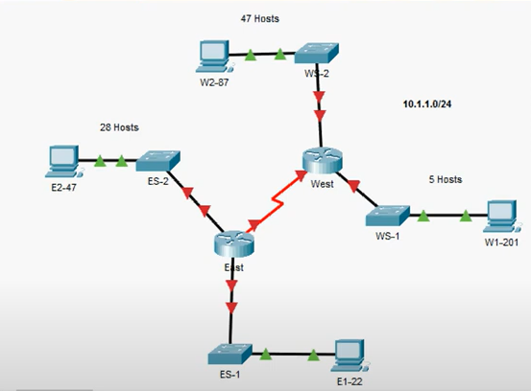

Scenario: You have given the network address: 10.1.1.0/24 by your customer. The host requirements are given based on the above topology. Please note that ES-1 LAN requires 11 hosts.
- Arrange the host requirements in a table format from the subnet or network that requires more hosts to the smaller number of hosts.
- Create the addressing design and document your design in a table format.
In IPv4, every subnet mask is 32 bits long. These bits are divided into:
- Network bits (ones): define the network portion.
- Host bits (zeros): define the number of available addresses for hosts.
To calculate the number of usable host addresses in a subnet, we use the formula:
2^n - 2
where n is the number of zeros (host bits) in the subnet mask.
The prefix (CIDR notation) is calculated by subtracting the number of host bits from 32:
Prefix=32−n
Once the prefix is determined, we calculate:
- Network Address: starting point of the subnet.
- First Usable Host: Network Address + 1
- Last Usable Host: Network Address + (2^n - 2)
- Broadcast Address: Last Host + 1
- Next Network Address: Broadcast Address + 1
1. WS2-LAN (47 hosts)
- 2^6−2=62→ n = 6, so prefix = 32 - 6 = /26
- Network Address: 10.1.1.0/26
- First Host: 10.1.1.1
- Last Host: 10.1.1.62
- Broadcast Address: 10.1.1.63
- Next Network Address: 10.1.1.64
2. ES2-LAN (28 hosts)
- 2^5−2=30→ n = 5, so prefix = /27
- Network Address: 10.1.1.64/27
- First Host: 10.1.1.65
- Last Host: 10.1.1.94
- Broadcast Address: 10.1.1.95
- Next Network Address: 10.1.1.96
3. ES1-LAN (11 hosts)
- 2^4−2=14→ n = 4, so prefix = /28
- Network Address: 10.1.1.96/28
- First Host: 10.1.1.97
- Last Host: 10.1.1.110
- Broadcast Address: 10.1.1.111
- Next Network Address: 10.1.1.112
4. WS1-LAN (5 hosts)
- 2^3−2=6→ n = 3, so prefix = /29
- Network Address: 10.1.1.112/29
- First Host: 10.1.1.113
- Last Host: 10.1.1.118
- Broadcast Address: 10.1.1.119
- Next Network Address: 10.1.1.120
5. WAN (2 hosts)
- 2^2−2=2 → n = 2, so prefix = /30
- Network Address: 10.1.1.120/30
- First Host: 10.1.1.121
- Last Host: 10.1.1.122
- Broadcast Address: 10.1.1.123
Note: We do not use broadcast addresses for network configuration.

Subnet Description | Number of Hosts Needed | Network Address/CIDR | First Usable Host Address | Last Usable Host Address | Broadcast Address
WS2-LAN | 47 | 10.1.1.0/26 | 10.1.1.1/26 | 10.1.1.62/26 | 10.1.1.63/26
ES2-LAN | 28 | 10.1.1.64/27 | 10.1.1.65/27 | 10.1.1.94/27 | 10.1.1.95/27
ES1-LAN | 11 | 10.1.1.96/28 | 10.1.1.97/28 | 10.1.1.110/28 | 10.1.1.111/28
WS1-LAN | 5 | 10.1.1.112/29 | 10.1.1.113/29 | 10.1.1.118/29 | 10.1.1.119/29
WAN | 2 | 10.1.1.120/30 | 10.1.1.121/30 | 10.1.1.122/30 | 10.1.1.123/30

- Configuration requirements:
Note: You will configure addressing on all devices and hosts in the network.
- Assign the first usable IP addresses in the appropriate subnets to [[East]] for the two LAN links and the WAN link.
- Assign the first usable IP addresses in the appropriate subnets to [[West]] for the two LANs links. Assign the last usable IP address for the WAN link.
- Assign the second usable IP addresses in the appropriate subnets to the switches.
- The switch management interface should be reachable from hosts on all of the LANs.
- Assign the last usable IP addresses in the appropriate subnets to the hosts.
- If the addressing design and implementation are correct, all hosts and devices should be reachable over the network.
Hint: you need to create a table for assigning IP addresses to each device and interface as based on the above configuration requirements. The table format is similar to the below table:
Device | Interface | Address | Subnet Mask | Default Gateway
East | Gig0/0/0 | 10.1.1.97 | 255.255.255.240 | N/A
East | Gig0/0/1 | 10.1.1.65 | 255.255.255.224 | N/A
East | Se0/1/0 | 10.1.1.121 | 255.255.255.252 | N/A
West | Gig0/0/1 | 10.1.1.113 | 255.255.255.248 | N/A
West | Gig0/0/0 | 10.1.1.1 | 255.255.255.192 | N/A
West | Se0/1/0 | 10.1.1.122 | 255.255.255.252 | N/A
ES-1 | VLAN 1 | 10.1.1.98 | 255.255.255.240 | 10.1.1.97
ES-2 | VLAN 1 | 10.1.1.66 | 255.255.255.224 | 10.1.1.65
WS-1 | VLAN 1 | 10.1.1.114 | 255.255.255.248 | 10.1.1.113
WS-2 | VLAN 1 | 10.1.1.2 | 255.255.255.192 | 10.1.1.1
PC E1-22 | NIC | 10.1.1.110 | 255.255.255.240 | 10.1.1.97
PC E2-47 | NIC | 10.1.1.94 | 255.255.255.224 | 10.1.1.65
PC W1-201 | NIC | 10.1.1.118 | 255.255.255.248 | 10.1.1.113
PC W2-87 | NIC | 10.1.1.62 | 255.255.255.192 | 10.1.1.1

- Attached screenshots for the configuration of the devices and interfaces.
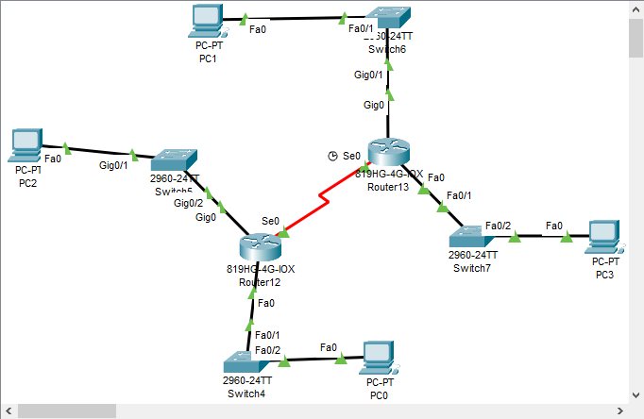
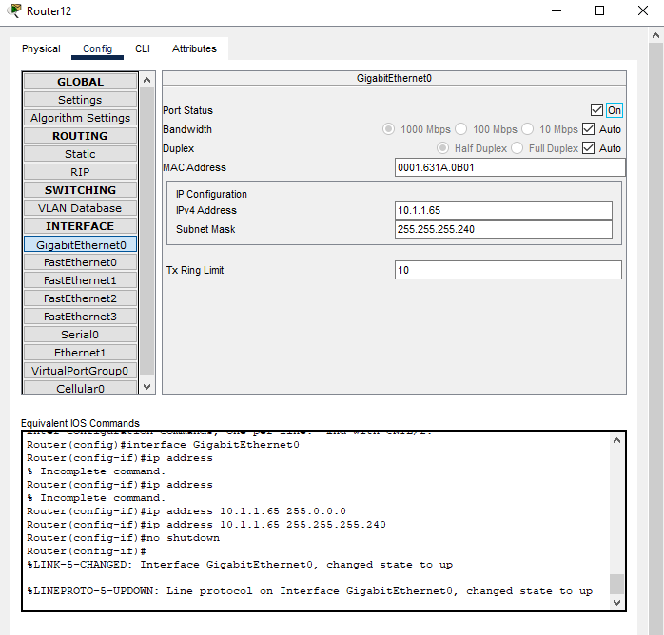

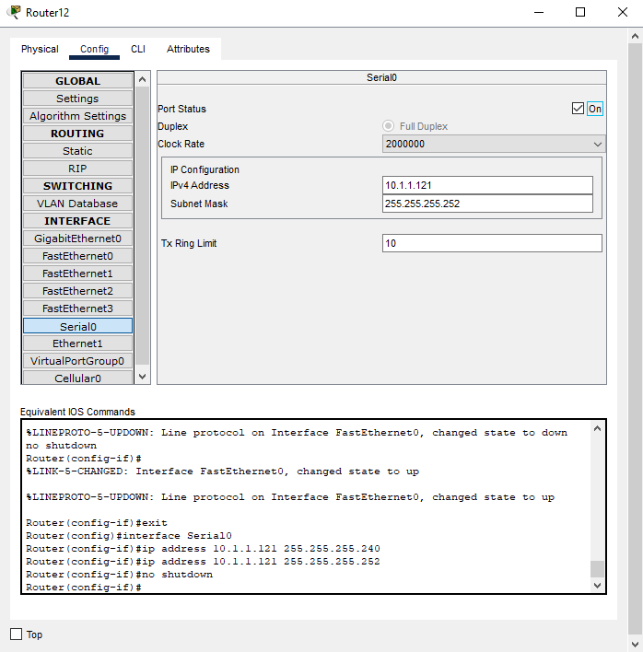

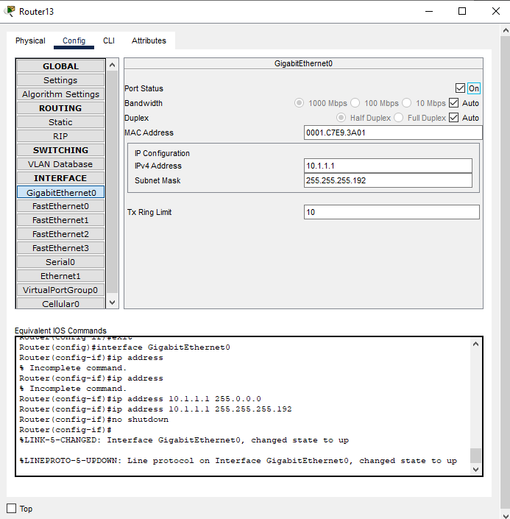

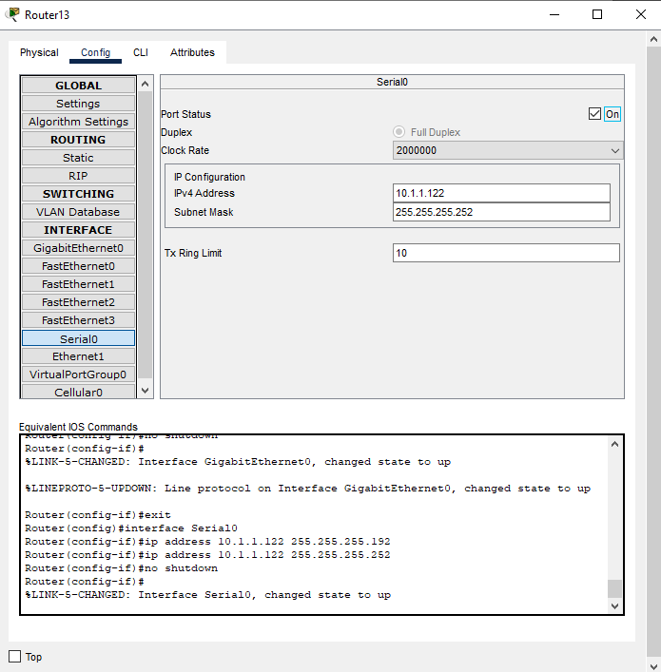

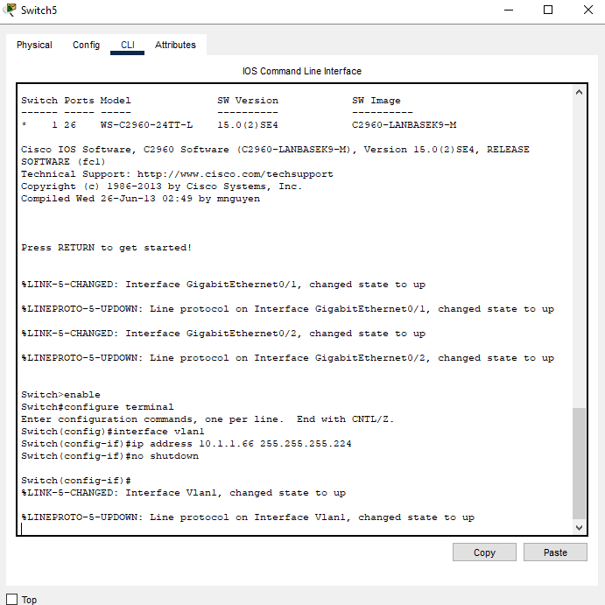

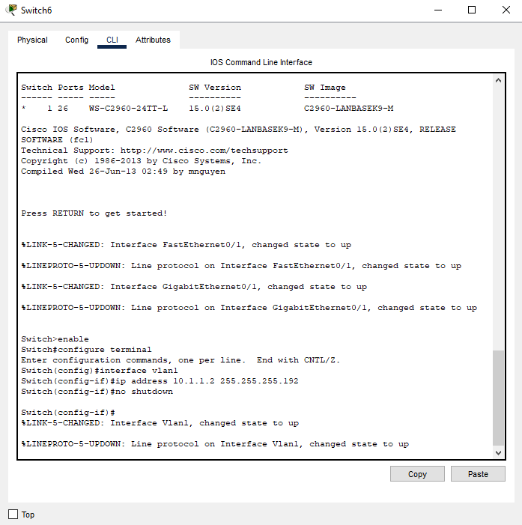

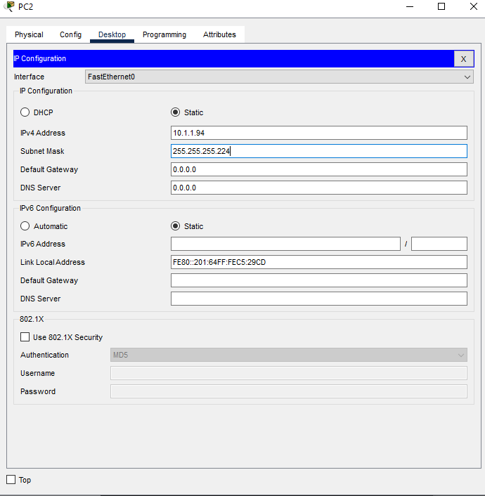

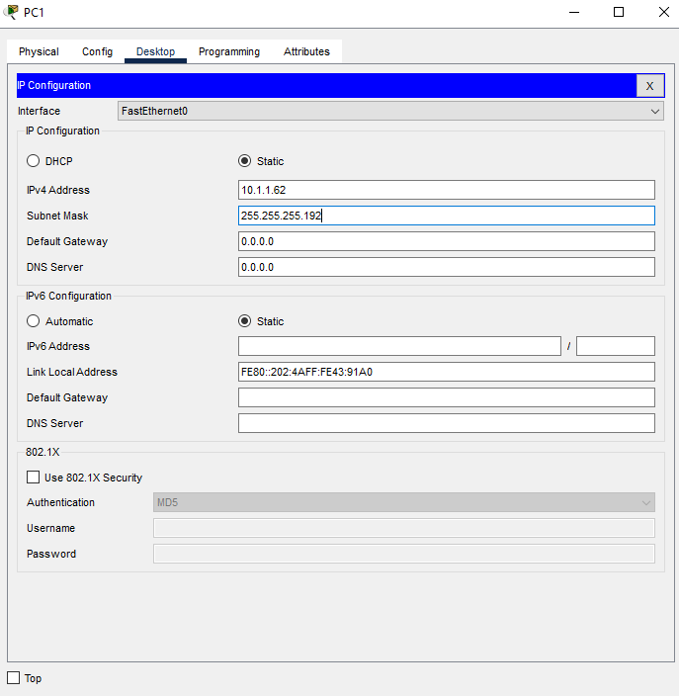

- Attach screen shots for the “Ping” between the PCs after configuration.
